1)Average Scores of Students by Subject
import numpy as np

student_scores = np. loadtxt ("/content/student_scores - student_scores - student_scores - student_scores.csv”, delimiter=",”, skiprows=1, usecols= (1, 2, 3, 4))
subjects = ["Math", "Science", "English", "History"]

average_scores = np. mean (student_scores, axis=0)

highest_subject = subjects [np. argmax(average_scores)]

print ("Average scores:", np. round(average_scores,2))
print ("Subject with highest average score:", highest_subject)

OUTPUT:
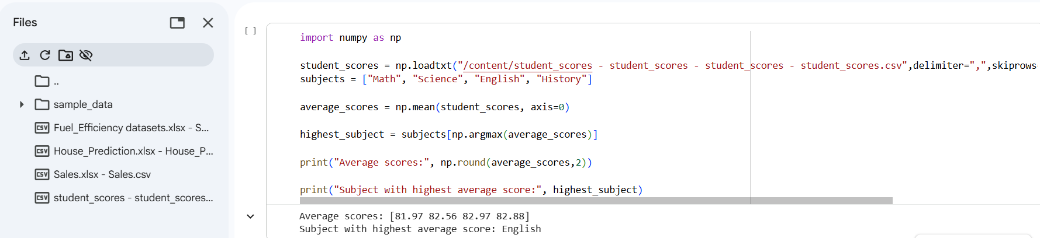

2)Average Price of Products Sold
import pandas as pd

df = pd. read_csv ("/content/Sales.xlsx - Sales.csv")

df. columns = df.columns.str. strip ()

df["Month_sales"] = df["Month_sales"]. astype(str). str. strip ()

df["Price"] = pd.to_numeric(df["Price"], errors="coerce")

november_data = df[df["Month_sales"]. str. contains ("Nov", case=False, na=False)]

average_price = november_data["Price"]. mean ()

print ("Average price in November 2023 (Past Month):", round (average_price, 2))

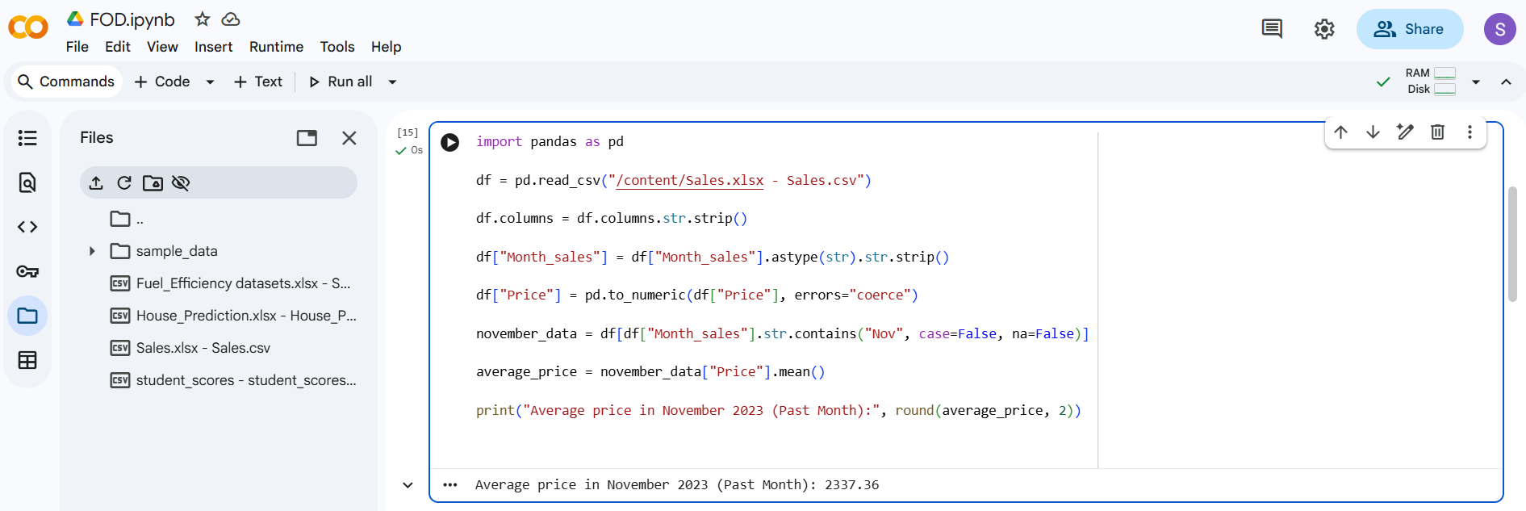
OUTPUT:

3) Average Sale Price of Houses with >4 Bedrooms
import numpy as np
house_data = np. loadtxt (
"/content/House_Prediction.xlsx - House_Prediction.csv",
delimiter=",",
skiprows=1
)
houses_more_than_4 = house_data [house_data [:, 0] > 4]
average_sale_price = np. mean (houses_more_than_4[: ,2])
print ("Average sale price of houses with more than 4 bedrooms:", round (average_sale_price, 2))

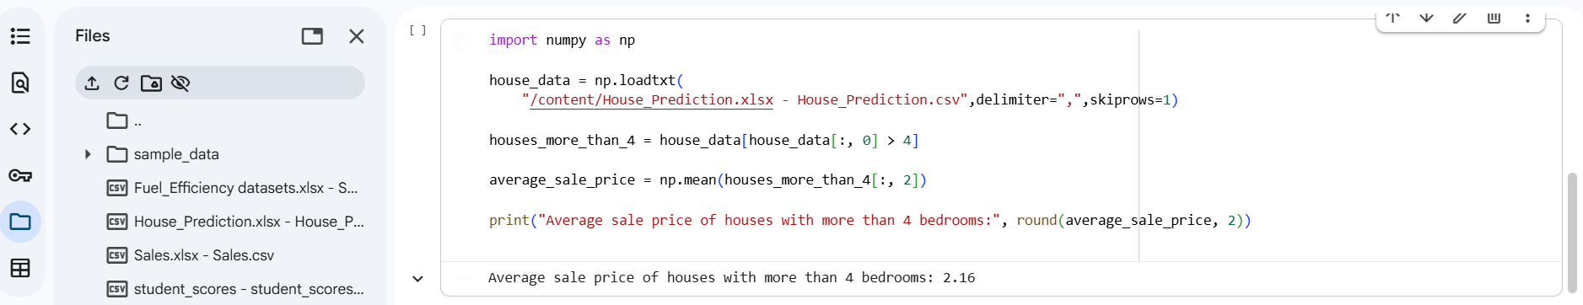
OUTPUT:
4)Total Sales and Percentage Increase in Quarterly Sales

import numpy as np
sales_data = np. loadtxt ("/content/Sales.xlsx - Sales.csv", delimiter=",", skiprows=1, usecols= (4,))
total_sales = np.sum(sales_data)
percentage_increase = ((sales_data [3] - sales_data [0]) / sales_data [0]) * 100
print ("Total sales for the year:", total_sales)
print ("Percentage increase from Q1 to Q4:", round (percentage_increase, 2), "%")

OUTPUT:
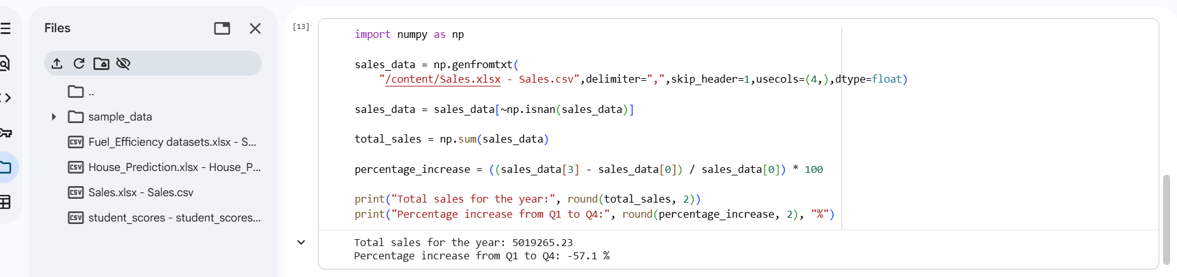

5) Average Fuel Efficiency and Percentage Improvement Between Car Models

import numpy as np
fuel_efficiency = np. loadtxt (
"/content/Fuel_Efficiency datasets.xlsx - Sheet1 - Fuel_Efficiency datasets.xlsx - Sheet1.csv”, delimiter=",”, skiprows=1, usecols= (2,))

average_efficiency = np. mean(fuel_efficiency)

if len(fuel_efficiency) >= 2:
car1_efficiency = fuel_efficiency[0]
car2_efficiency = fuel_efficiency [1]
percentage_improvement = ((car2_efficiency - car1_efficiency) / car1_efficiency) * 100

print ("Average fuel efficiency:", round (average_efficiency, 2), "mpg")
print ("Percentage improvement from car 1 to car 2:", round (percentage_improvement, 2), "%")
else:
print ("Not enough data to compare two car models. Please ensure your dataset has at least two entries.")

OUTPUT:
